Vehicle Video Server

Proposal

Date: 31 August 2022

Co-Confidential

Attn: Roger Yeo / Adrian / Sandy From: Ma Zai Hang
Neo Kian Hong / Lin bing
To: STELS Fax: 64649500
Fax: Tel: 67507007
Tel: Total: 17 pages
(Inclusive of this page)

- Objective

This document is a business proposal to design / develop / fabricate the Video Server for Terrex-Gen5 Vision System, according to the technical specification requirements.

- Work scope & Responsibility

TEAMONE

- To work as a team together with Customer for video server and iDDP in system architecture design.
- To provide electronic hardware / mechanical / thermal design and related software development. (Refer to technical proposal in annex 1)
- To design and fabricate the related test equipment and develop test software for Video Server hardware performance / acceptance test.
- Develop or supply the toolkits / application software for secondary development to user’s request.
- To fabricate a minimum of 1 working prototypes (or quantity as required)
- To assist customer to integrate video / control functions / software into the video server.
- To work with customer for vehicle integration and test.
- To provide technical support during operation of ARSS Scenario Generation and Performance Validation.
- To provide technical support for EQT, EMI/EMC test.
- To provide 1-year hardware quality warranty service.
- To provide fabrication service for video server production, if any manufacturing contract is awarded to the customer/TeamOne Team.

STELS (Customer)

- System level specification, including the hardware requirements of the features for video processing function.
- To develop the software on video server to video processing function, excluding interface driver / 360 degree field of stitched view / video CODECs functions.
- To provide instructions of operating procedure & performances.
- To conduct the safety / reliability analysis.
- To conduct EQT, EMI/EMC, including booking the test facilities for the test.
- To conduct system integration / test in vehicle.
- To conduct ARSS Scenario Generation and Performance Validation.

- Schedule and milestone

- PDR: in 8 weeks upon project start, system design completed.
- CDR: in 28 weeks upon project start, initial design ready for review.
- Prototype completion in 9 months from the date of PO reception.

Annex 1. Technical Proposal for Video Server box.
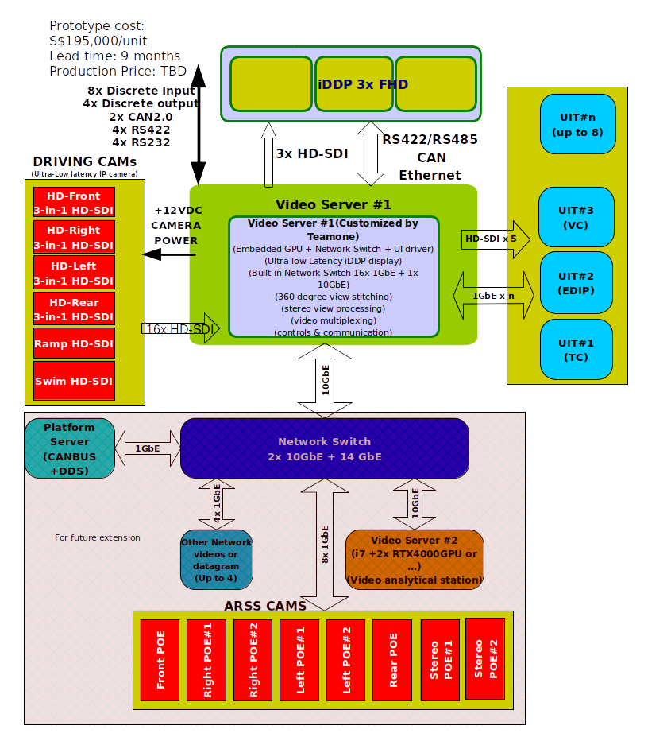

Figure 1. Terrex-Gen5 Video Server & iDDP ---- (with built-in Network switch & embedded GPU)
Annex 2. Video Server proposed functionalities and performances

Item | Description | Characteristics | Remark
1 | General Requirements
1.1 | Multiple SDI/H.264(H.265) input and output | In rugged enclosure
1.2 | Basic functions | Supports:  Video distribution in HD-SDI  Networking Video stream  ATD/R/T  Video Stitching  Video Augmentation  Video Enhancement  Video CODEC  Video Fusion  Video Embedded META data
1.3 | Support additional GPU card, RTX3000 or equivalent | Support up to Jetson AGX Xavier module
1.4 | Responding to UIT/iDDP | for video source changing, view selection, without affecting each other
1.5 | Video screen image / info. Contents | including:  PIP  Stitched view  Day/night view  Sight slewing  ATR augmentation  Dynamic OSD
1.6 | Interlaced and non-HD video input | performing de-interlacing and size scaling function
1.7 | Output video backup | provide redundant video feeds for the crew
1.8 | Output screen when no respective video feed | Raster blue screen
1.9 | Output screen when no respective video feed | Raster blue screen
1.10 | BIT | System , I/O , Networking
1.11 | GPU maximum loading | <70%
1.12 | CPU reserved capacity | >50%
1.13 | Documentation | To provide design / specification of interface / CPU / GPU / FPGA.  1. CPU/FPGA/GPU: Xilinx UltraScale SoC  2. GPU/CPU: Nvidia Jetson AGX Xavier module
2 | Video Interface
2.1 | Support input camera interface | ARSS / Stitched view  BEV  Stereo Vision  Driving | Through RS422, RS232, Etherent
2.2 | Number of input channels | Up to 20x HD-SDI or others  Support up to 16x H.264 video stream playback (from network or storage)  1x Audio | HD/SD-SDI configurable
2.3 | Number of output channels | 8x HD-SDI with  redundancy of H.265 stream over IP  1x optional when a GPU is added
2.4 | Direct HD-SDI feed | 3x feed for iDDP (w/ spare channels)  5x feed for UIT  optional 1x feed when a GPU is added
2.5 | Glass-to-glass latency | 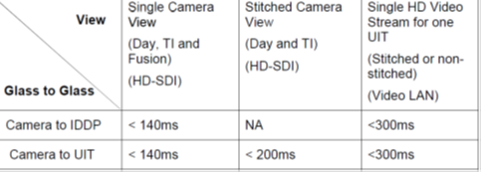
  HBM >16000V
2.6 | Independency of video feed | all video feed shall be able to operate independently, without affecting each other
2.7 | Number of auxiliary feed | 7x stream over IP, playback enable | H.264/265
2.8 | Latency of ARSS view with ATD/R/T | <300ms | to be confirmed together with STELS software team
2.9 | To propose video format to iDDP and UIT | to meet the criteria of latency | Primary video: HD-SDI  auxiliary feed: H/265 over IP
2.10 | Estimated video latency | <140ms for UIT & iDDP single view  <200ms for stitched view in HD-SDI  <300ms for auxiliary feed in H.265 format | iDDP latency would be better, to be less than 90ms. (if iDDP is from Teamone provided camera delay is <40ms)
2.11 | Actual measurement of system | upon availability of hardware
2.12 | Ethernet Switch built-in | 1x 10G Ethernet + 8x GbE to external
2.13 | Engineering tools from Network | TBD | Remote diagnosis / configuration / operation
2.14 | Communication / control interface | Ethernet through Ethernet switch  2x CAN (MIL-CAN)  4x RS422  4x RS232
2.15 | CAN terminal | No 120 Ohm termination resistor should be put
2.16 | Supported input video format | HD-SDI -- SMPTE292  H.264/265 over IP
2.17 | Supported output video format | HD-SDI -- SMPTE292  H.264/265 over IP
3 | Discrete I/Os
3.1 | Discrete 24v/0v input from vehicle | 8x ch input, 4x ch output
3.2 | Discrete 24v/0v input from vehicle | Opto-isolator input / OC output
3.3 | Discrete 24v/0v input from vehicle | Ref. with vehicle power return

4 | Power supply
4.1  4.2 | Operating power voltage |  | Nominal: 28VDC  Low: 18VDC  High: 32VDC  MIL-STD-1275B  Power consumption:  Nominal: 250W continuous  Peak: 450W  Maximum: 350W continuous | Based on estimation of 60%, 100% , 75% loading for nominal, peak and maximum consumption
5 | System clock
5.1 | Timing synchronization function |  | Input: 1PPS from navigation system  output for: video stitch and other functions
5.2 | 1ppS re-distribution |  | to platform cameras
5.3 | NTP connection |  | RFC5905 NTP protocol for time sync. | Through Ethernet
5.4 | time stamping and video telemetry |  | MISB0605.6 for uncompressed video  MISB0604.3 for compressed video
6 | A/V recorder / Player ---- Optional
6.1 | Recorder |  | for UIT screens  for all camera input video
6.2 | Recording method |  | Loop recording  with time stamping information
6.3 | Audio recording |  | sync. With timing | MPEG
6.4
6.4.1 | Input |  | HD-SDI or others (TBD)
6.4.2 | Data extraction |  | Secure way | USB or Ethernet.
6.4.3 | Playback function |  | From VSR, x2/x4/x8 speed, playback portal
6.4.4 | Trigger / Arm signal input |  | 24V/0V input from DDS information package.  OSD on recorded video for indication of above signals
6.4.5 | ARM signal |  | Start recording on VC/Gunner/Centre UIT when switched on. Stop if it is released.
6.4.6 | Trigger signal |  | Start recording on VC/Gunner/Centre UIT , 15 second pre- and 30 sec post- when switched on. Stop if it is released after 30 seconds.
6.5 | Storage media
6.5.1 | Recorded video for platform camera input |  | Number of: 24x ch  Total media volumn size: 2TBytes | TBD
6.5.2 |  |  | Number of: 24x ch  Total media volumn size: 2TBytes
6.5.3 | Functional check for preview |  | for each video claps
7 | DDS connectivity ---- Client (Optional)
7.1 | OMG DDS security |  | Protocol (RTI Connext DDS  Secure 5.3.1 and RTI Connext DDS Secure plugins
7.2 | Video distribution protocol |  | RTP for H.265 over IP | RTP
8 | Video Control and display functions
8.1 | ARSS and stitched view
8.1.1 | Involved cameras |  | respective view of day and all ti cameras on platform
8.1.2 | Output video |  | Available on UITs upon request  Optionally available on iDDP upon request  up to 180degree / section  reverse / normal view
8.1.3 | Video truncation |  | to 3x 1920x1080@30Hz UIT output
8.1.4 | Bearing information maintaining |  | Maintain the information in original input video
8.1.5 | BMS function |  | Touch to slew from BMS
8.1.6 | Video cross section |  | able to cross section stitched view | To be done in AGX Xavier module?
8.1.7 | FOV display |  | FOV selection from screen
8.1.8 | Zooming of AOI |  | AOI zoom in
8.2 | Potential growth and tools (with additional GPU card and software from STELS)
8.2.1 | Real-time ATD/ R/ T augmentations |  | on Stitched video  on individual video streams  based on user selection and from other systems
8.2.2
8.2.3 | Augmentation data |  | Pushed from DDS  For varies of type of graphics, text
8.2.4 | Calibration tools / features |  | Available for operators to calibrate upon vehicle configuration | Reference table for correction based on calibration
8.2.5 | Tools |  | Available for engineering
8.3 | Video Image enhancement
8.3.1 | Features |  | Sensor Fusion  Contrast adjustment  Brightness manipulation  Warp correction | for all channels
8.3.2 | Blending view |  | For stitched view
8.4 | Target Detection / recognition functions (Growth Potential)
8.4.1 | ATD/R function |  | On video input from EO cameras  on video input from TI
8.4.2 | ATD/R function vehicle speed range |  | 0~32KMph  for stationary / moving human/vehicle objects | Figure 2: Target/ Object Classes Tree
8.4.3 | ATD/R |  | object classification / confidence level based on training | Figure 2: Target/ Object Classes Tree
8.4.4 | Machine learning |  | Human / vehicle | Figure 2: Target/ Object Classes Tree
8.4.5 | target recognition |  | Level 3/4 | Figure 2: Target/ Object Classes Tree
8.4.6 | Detection |  | > level 2 | Figure 2: Target/ Object Classes Tree
8.4.7 | Improve progressively |  | During trail
8.4.8 | Deep learning / Machine vision |  | For development
8.4.9 | ATD/R performance |  | Table 3: ATD/ R at 90% Probability of Detection (PD)  False Alarm Rate (FAR) <20%  Miss detection (false negative) rate <10%
8.4.10 | ATT features |  | As described
8.4.11 | Result output in META data |  | As described
8.4.12 | Processing time for ATD/R/T and overlay of information on OSD |  | <50ms | Quite difiicult???
8.5 | Video on-demand selection and connectivity
8.5.1 | View |  | For surroundings
8.5.2 | Command |  | From DDS for layout information
8.5.3 | Video over IP through DDS |  | As requried
8.5.4 | Layout size |  | 1920x1080 @ 30Hz  Multiple sub-images
8.5.5 | Created layout properties |  | Video Source ID  Start co-ordination of the source image  Start co-ordination of image in layout  Sub-image width and height
8.5.6 | Health status of BIT |  | Pushed to DDS
8.9 | Respond delay to a command from DDS |  | <TBD
8.9.4 | current layout enumeration |  | TO DDS
8.9.5 | Number of sub-images in one layout |  | >=16 video source (can be repeated on same source)
8.5.10 | Video latency difference |  | <1 or 2 frame between video sources
8.5.11 | Not occupied area in layout |  | Fill in black color
8.5.12 | Error to create video layout |  | fill in the error area with black color
8.6 | OSD and ARSS view
8.6.1 | OSD upload |  | From UIT
8.6.2 | Tools for OSD editing, generation |  | Toolkit
8.6.3 | Color of OSD |  | 256x color
8.6.4 | resolution of OSD |  | 1920x 1080  1024x 768…….
8.6.5 | OSD transparency |  | Alpha channel available
8.6.6 | Retrieval of OSD |  | Available
8.6.7 | Upload/removal of OSD |  | Shall not affect system stability
8.6.8 | OSD display |  | Resizable upon display size
8.6.9 | Protocol for OSD uploading |  | Shall be provided to customer
8.6.10 | Development toolkit for OSD |  | to be developed
8.6.11 | ARSS requirement |  | TBD
8.6.12 | Proposal for ARSS |  | Shall be provided to customer
8.7 | Documentation and Others (based on mass production order)
8.7.1 | ATP |  | 1month notice
8.7.2 | Technical support |  | For prototype  For first 2 articles  for subsequent product units
8.7.3 | Technical support |  | For integration of system to vehicle
8.7.4 | Test plan |  | >1 month prior to test
8.7.5 | Test result |  | <1 month after test
8.8 | Tools and trainings
8.8.1 | Engineering development toolkit |  | Available
8.8.2 | Training of engineering development |  | Available
8.8.3 | Training contents |  | As required in paragraph
8.8.4 | Provisions |  | Available
8.8.5 | Hardware package for training |  | Available
8.8.6 | Software package for training |  | Available
9 | Qualification standards reference
9.1 | Applicable documents |  | MIL-STD-461E  MIL-STD-464C  MIL-STD-1275B  MIL-STD-188-124B  IEC-61000-4-2
9.2 | EMI / EMC Requirement |  | CE 102  RE102  CS101/114/115/116  RE103
9.2.1 | Standard for qualification |  | MIL-STD-461E
9.2.2 | Waiver of test item |  | To be approved by customer
9.2.13 | EMI/EMC test report |  | a. EMC Control Plan  b. EMC Test Plan/Procedure  c. EMC Test Report
9.3 | Power requirement |  | MIL-STD-1275B  Test Plan  Test report | report within 1 month after test
9.4 | Environmental Qualifications
9.4.1 | Applicable documents |  | MIL-STD-810E  IEC 60529  STANAG 2895
9.4.2 | Test requirements |  | Table 5/6/7/8/9
9.5 | Reliability / safety & workmanship
9.5.1 | Applicable Documents |  | MIL-STD-882E  AMCP 706-125  MIL-HDBK-454B
9.5.2 | Excessive Temperature |  | 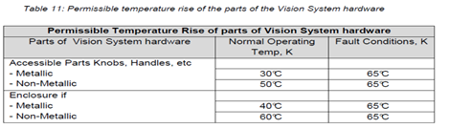
9.5.2.1 | Wiring
9.5.2.2. | Mechanical Hazard
9.5.3 | System Safety Requirements for Software |  | Video Server and IDDP is identified to have Software Criticality Index 1 (SwCI 1) for the following hazards:  a. Driver/ Commander misled by wrong camera video display  b. Loss of video display during closed hatch driving
9.5.4 | Safety Critical Item (SCI) and Reliability Critical Items (RCI) |  | Video Server, IDDP, BEV Cameras and Platform Cameras (Driving Camera) are  classified as Reliability Critical Item
10 | Acceptance test
10.1 | Contract Data Requirements List (CDRL) |  | TBD
10.2 | Integrated Logistics Support (ILS) Requirements |  | TBD
10.3 | Reliability & Maintainability Requirements |  | TBD
10.4 | Quality Assurance |  | TBD
10.5 | Software Development Requirements |  | TBD
10.6 | ARSS Requirements |  | TBD
10.7 | Deliverables and Schedule |  | TBD

Annex 3. System Architecture
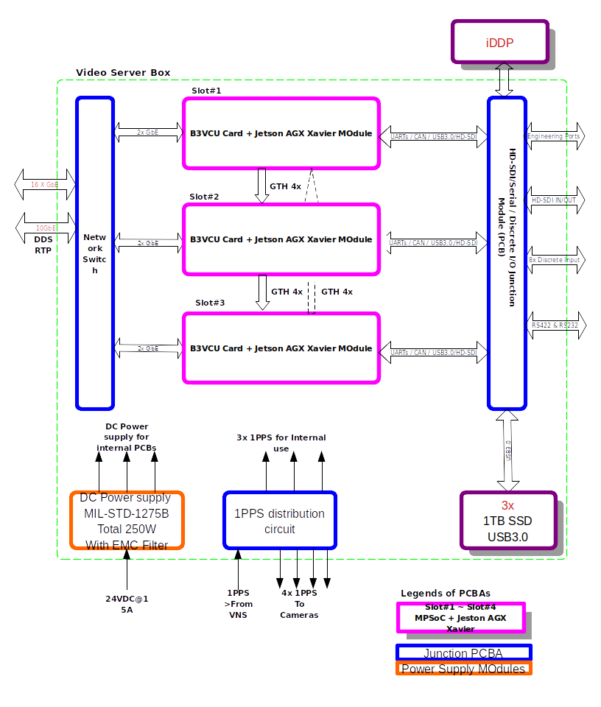
Figure 1. Video server internal functional block diagram
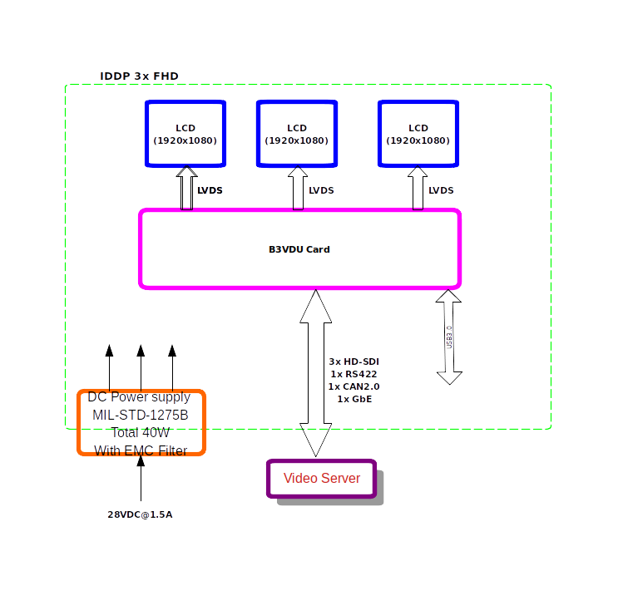
Figure 2. iDDP 3x FHD internal functional block diagram

Figure 3. Video processing cell block diagram (as per in slot #1~3 in figure 2)
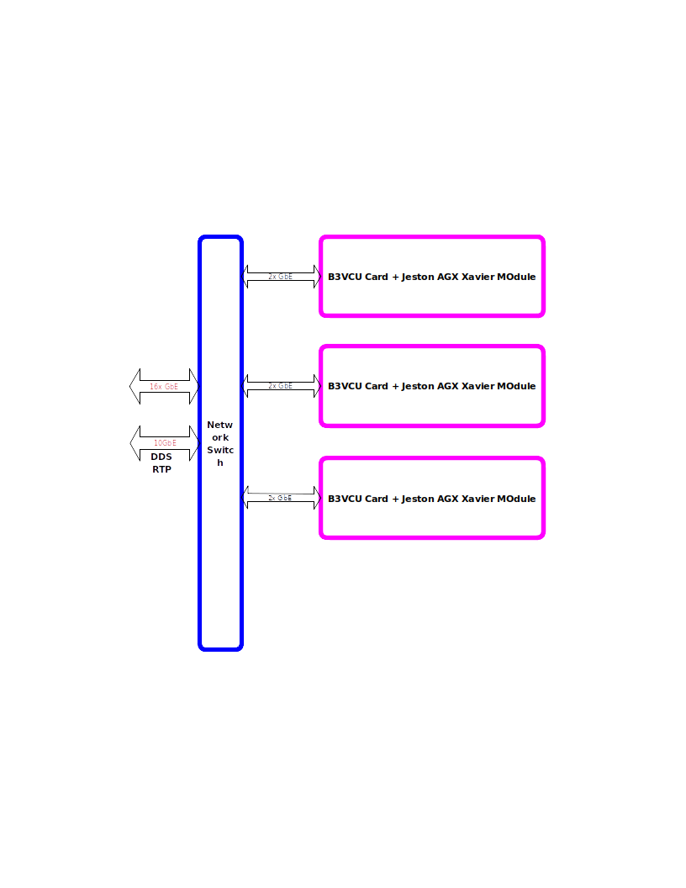
Figure 4. Networking switch diagram in video server.

