|  |  |
| --- | --- |
| **Title:** | **Software Requirements Specification of Video Server for Project Terrex Gen 5** |
| **Total Pages:** | **11** |

|  |  |  |  |
| --- | --- | --- | --- |
|  | **Prepared By:** | **Vetted By:** | **Approved By:** |
| **Name** |  | Chee Yong Way | Tan Sung Kai Dennis |
| **Signature** |  |  |  |
| **Appointment** | Software Engineer | Software Lead | Software Head |
| **Date** | stk_submitdate | stk_revieweddate | stk_approvaldate |

|  |  |  |  |  |
| --- | --- | --- | --- | --- |
| **Revision Record** | | | | |
| **RevNo.** | **Date Revised** | **Page(s) affected** | **Change Description** | **Reason(s) for Change** |
| A | 2023-01-16 | - | New release | - |
|  |  |  |  |  |
|  |  |  |  |  |
|  |  |  |  |  |
|  |  |  |  |  |
|  |  |  |  |  |

Revision Instructions

1. Method of revision will be through the issue of new document.

2. Revision No. will be advanced by one letter.

3. Change Description and Reason(s) for Change to be recorded.

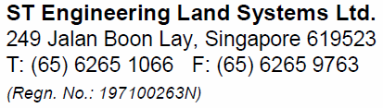

Contents

1 INTRODUCTION 4

1.1 Purpose 4

1.2 Scope 4

1.3 Intended Audience 4

1.4 Acronym & Abbreviation 4

1.5 Definition 4

1.6 Reference Documents 5

1.7 Assumption and Dependencies 5

1.8 Overview Of This Document 5

2 Overall description 6

2.1 Product Perspective 6

2.2 System Interface 7

2.2.1 User Interfaces 7

2.2.2 Hardware Interfaces 7

2.2.3 Software Interfaces 7

2.2.4 Communications interfaces 7

2.2.5 Memory Constraints 7

2.2.6 Site Adaption Requirements 7

2.3 Functional requirements 7

2.3.1 System Feature 1 7

2.4 Safety Features 9

2.5 Performance requirements 9

3 Use Case Analysis Model 10

3.1 Actor List 10

3.2 Use Case Modelling 10

3.3 Use Case 10

4 Design Constraints / Limitation 10

4.1.1 Hardware Constraints / Limitation 10

4.1.2 Software Constraints / Limitation 10

5 Software System Atributes 10

5.1.1 Reliability 10

5.1.3 Availability 11

5.1.4 Security 11

5.1.5 Maintainability 11

5.1.6 Portability 11

6 Other Requirements 11

7 Annex 11

# INTRODUCTION

## Purpose

The purpose of the Software Requirement Specification (SRS) document is to formally describe the software requirements of the Video Server for Terrex Gen 5 (TG5). It serves as a guide for engineers who are responsible in engineering and developing the software. The document should cover all of the information necessary to design, develop and test the software.

## Scope

The scope of this Software Requirements Specification (SRS) covers the following areas for the Video Server developed for Project Terrex Gen 5:

* The capabilities, interface and performance requirements.

## Intended Audience

The intended audience for this document is written for project members for STELS and Team One.

## Acronym & Abbreviation

| **Abbreviation** | **Definition** |
| --- | --- |
| CSCI | Computer Software Configuration Item |
| DBW | Drive-By-Wire |
| MCM | Mobility Control Module |
| MSS | Mobility Selector Switch |
| SRS | Software Requirements Specification |
| SSS | System / Subsystems Specification |
| VSR | Video Server |

## Definition

| **Term** | **Definition** |
| --- | --- |
| Shall | Mandatory requirement |
| Should | Desirable requirement |
| Will | Mandatory requirement outside the scope of this document |
| May | Desirable requirement outside the scope of this document |
| Computer Software Configuration Item (CSCI) | An aggregation of software components that satisfies an end use function and is designated for separate configuration management by the acquirer. |
| Data Distribution Service (DDS) | The Data Distribution Service (DDS) is an Object Management Group (OMG) machine-to-machine (sometimes called middleware) standard that aims to enable scalable, real-time, dependable, high performance and interoperable data exchanges using a publish-subscribe pattern. |
|  |  |

## Reference Documents

The documents listed below were either used to create this document or are referenced in it:

| DOCUMENT NO. | TITLE |
| --- | --- |
|  |  |

## Assumption and Dependencies

The assumption shall be the following:

* Any new requirements should only affect the system behavior and performance and should not affect the software architecture designed.

## Overview Of This Document

Section 1: Introduction: Define purpose and scope of this document, the document structure, the document intended audience and the references made.

Section 2: Overall Description: Describe the product perspective, the system interface, the functional requirements, the safety features, and the performance requirements.

Section 3: Design Constraints/Limitation: List of hardware software constraints.

Section 4: Software System Attributes: The list of expecting attributes of the developed software.

Section 5: Other Requirements

# Overall description

This chapter describes the overview of the Video Server where the software is to be designed and developed.

## Product Perspective

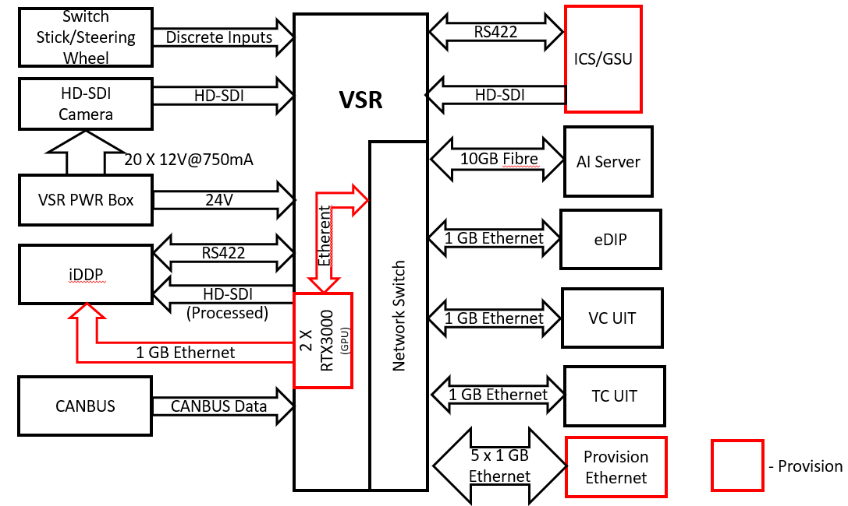

Figure 1: Video Server Interface Block Diagram

## Camera Placement

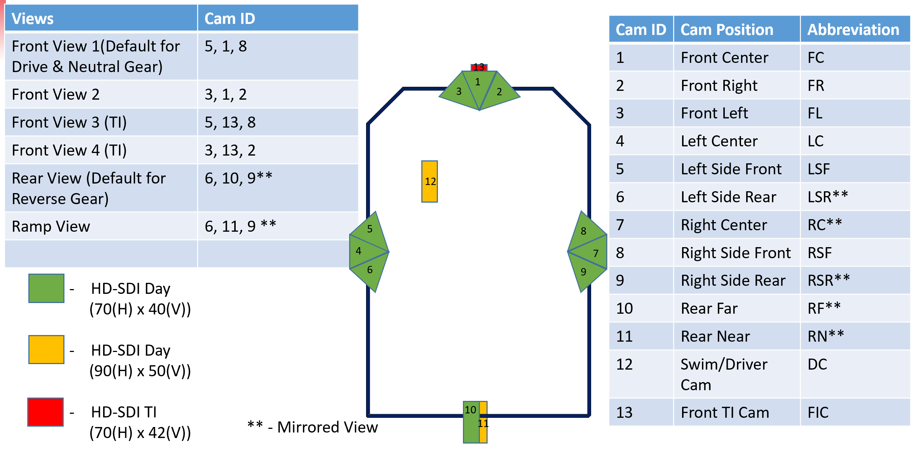

## System Interface

### User Interfaces

| **ID No** | **REQUIREMENTS** |
| --- | --- |
|  | Not Applicable |

### Hardware Interfaces

| **ID No** | **REQUIREMENTS** |
| --- | --- |
|  | Not Applicable |

.

### Software Interfaces

| **ID No** | **REQUIREMENTS** |
| --- | --- |
|  | Not Applicable |

### Communications interfaces

| **ID No** | **REQUIREMENTS** |
| --- | --- |
|  | Not Applicable |

### Memory Constraints

| **ID No** | **REQUIREMENTS** |
| --- | --- |
|  | Not Applicable |

### Site Adaption Requirements

| **ID No** | **REQUIREMENTS** |
| --- | --- |
|  | Not Applicable |

## Functional requirements

### Network Configuration

Video Server

AI Server

Platform Server

Network Switch

Driver UIT

TC UIT

VC UIT

A

B

C

H

E

F

G

D

|  |  |  |  |  |
| --- | --- | --- | --- | --- |
| Device | Port | Link Speed | IP Address | Subnet Mask |
| Video Server | A | 10 Gbps | 10.1.153.61 | 255.255.255.0 |
| Video Server | B | 1 Gbps | 10.1.154.61 | 255.255.255.0 |
| AI Server | C | 10 Gbps | 10.1.153.71 | 255.255.255.0 |
| AI Server | D | 1 Gbps | 10.1.154.71 | 255.255.255.0 |
| Platform Server | E | 1 Gbps | 10.1.153.51 | 255.255.255.0 |
| Driver UIT | F | 1 Gbps | 10.1.153.101 | 255.255.255.0 |
| TC UIT | G | 1 Gbps | 10.1.153.102 | 255.255.255.0 |
| VC_UIT | H | 1 Gbps | 10.1.153.103 | 255.255.255.0 |

### Software Architecture

Platform Server

Video Server

Driver UIT

TC UIT

VC UIT

AI Server

RTP Video Stream

Stream Request

Stream Request

Stream Request

Stream Request

Ack Msg

RTP Time Stamp

Ack Msg

Ack Msg

Ack Msg

The above diagram shows the software architecture of the Video Server. The Use Case is detailed in Section 3.2.

### Time Synchronization

A network time synchronization (IEEE PTP1588) shall be used to synchronize between multiple computers in a network.

| **ID No** | **REQUIREMENTS** |
| --- | --- |
|  | Video Server shall implement Precise Time Protocol daemon as a SLAVE mode to synchronize its internal computing units’ system time at startup. |
|  | The PTP daemon shall operate in SLAVE mode on the 1Gbps network. |

### ARSS Services

UIT shall be able to request for a configurable layout via Platform Server to Video Server. The UIT shall be able to request for up to 20 RTP streams, and each RTP stream can support up to 20 video layouts. The Sequence Diagram shows the message sequence.

| **ID No** | **REQUIREMENTS** |
| --- | --- |
|  | The Video Server upon successful startup shall broadcast VDS_Heartbeat message to Platform Server. |
|  | UIT shall request for RTP stream via Platform Server.  Platform Server shall act as a gateway to communicate directly to Video Server to request stream and handle Acknowledgement messages. |
|  | The Video Server shall listen for VDS_Setup message from Platform Server and send an Ack message back to Platform Server.  Video Server shall check the layout configuration and output a RTP stream and RTP timestamp to a destination IP address and port number. |
|  | When stream is setup successfully, Video Server shall publish the RTP stream and VDS_RTP_Timestamp message to the requester (UIT and AI Server) |
|  | The Video Server shall listen for VDS_Teardown message from Platform Server and send an Ack message back to Platform Server  The Video Server shall check and terminate the requested stream. |
|  | The Video Server shall be able to output up to 20 RTP streams simultaneously to destinations with multiple IP addresses and ports. |

#### UDP Datagram

UDP Datagram header

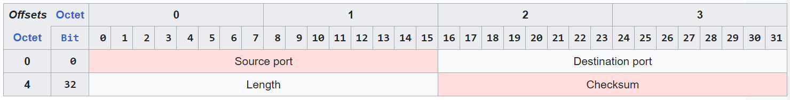

Payload

8

#

|  |  |
| --- | --- |
| **Field** | **Description** |
| Source Port | This field identifies the sender's port, when used, and should be assumed to be the port to reply to if needed. |
| Destination Port | This field identifies the receiver's port and is required. |
| Length | This field specifies the length in bytes of the UDP header and UDP data. The minimum length is 8 bytes, the length of the header. The field size sets a theoretical limit of 65,535 bytes (8-byte header + 65,527 bytes of data) for a UDP datagram. However the actual limit for the data length, which is imposed by the underlying [IPv4](https://en.wikipedia.org/wiki/IPv4) protocol, is 65,507 bytes. |
| Checksum | The [checksum](https://en.wikipedia.org/wiki/Checksum) field shall be used for error-checking of the header and data. |
| Payload | The payload data defined in 2.4.4.2 |

| **ID No** | **REQUIREMENTS** |
| --- | --- |
|  | The Video Server shall use UDP datagram to receive commands and transmit heartbeat messages between Platform Server and Video Server. |
|  | The UDP Datagram library shall take care of the integrity of the message by checking the checksum of the message. |

#### UDP Payload data

The UDP Payload data carries the following messages: VDS_Heartbeat, VDS_Setup, VDS_Teardown, VDS_RTP_Timestamp messages.

|  |  |  |  |  |
| --- | --- | --- | --- | --- |
| Octet | 0 | 1 | 2 | 3 |
| 0 | Header | | Type | Version |
| 4 | SequenceNumber | | | |
| 8 | Timestamp | | | |
| 12 | Timestamp | | | |
| 16 | Message data | | | |

Data description

|  |  |  |  |  |
| --- | --- | --- | --- | --- |
| **Field** | **Data Type** | **Resolution** | **Range** | **Remarks** |
| Header | UINT32 |  |  | A fixed message header: 0x5354 |
| Type | UINT8 |  |  | Message type:  0x00: Undefined  0x01: Heartbeat  0x02: Acknowledge  0x10: Stream Setup  0x11: Stream Teardown  0x21: Stream List Request  0x22: Stream List |
| Version | UINT8 |  |  | Version type for message type  Default: 0x00 |
| SequenceNumber | UINT32 |  | 0…2^32 | Incremental running sequence for loss packet detection |
| Timestamp | UINT64 | 1us / bit | 0…2^64 | Time since epoch in microseconds |

#### Heartbeat Message

| **ID No** | **REQUIREMENTS** |
| --- | --- |
|  | The Video Server shall send a Heartbeat message periodically (a repetitive rate of 500ms) with the following statuses:   * Version number * Serial number of Video Server * CPU loading of all computing units * Memory usage of all computing units * Temperature of all computing units * BitReportMask |
|  | When Platform Server did not receive a heartbeat message for more than 5 consecutive times or 2.5 seconds, it shall deem as a loss communication with Video Server. |
|  | The SequenceNumber shall start from 0. It shall increment by 1 at every publish. The SequenceNumber shall restart to 0 if it reaches maximum value. |

|  |  |  |  |  |
| --- | --- | --- | --- | --- |
| **VDS_Heartbeat**  Repetition Rate: 500ms | | | | |
| Octet | 0 | 1 | 2 | 3 |
| 0 | Header | | Type | Version |
| 4 | SequenceNumber | | | |
| 8 | Timestamp | | | |
| 12 | Timestamp | | | |
| 16 | SerialNumber | | | |
| 20 | SysLoad0 | SysLoad1 | SysLoad2 | SysLoad3 |
| 24 | SysMem0 | SysMem1 | SysMem2 | SysMem3 |
| 28 | SysTemp0 | SysTemp1 | SysTemp2 | SysTemp3 |
| 20 | VersionMajor | VersionMinor | VersionSubMinor | Variant |
| 28 | iDDP View | NumRTPStreams | Reserved | Reserved |
| 32 | BitReportMask | | | |

Data description

|  |  |  |  |  |
| --- | --- | --- | --- | --- |
| **Field** | **Data Type** | **Resolution** | **Range** | **Remarks** |
| Header | UINT32 |  |  | A fixed message header: 0x5354 |
| Type | UINT8 |  |  | Message type:  0x00: Undefined  0x01: Heartbeat  0x02: Acknowledge  0x10: Stream Setup  0x11: Stream Teardown |
| Version | UINT8 |  |  | Message version:  0x00 |
| SequenceNumber | UINT32 |  | 0…2^32 | Incremental running sequence for loss packet detection |
| Timestamp | UINT64 | 1us / bit | 0…2^64 | Time since epoch in microseconds |
| SerialNumber | UINT32 |  | 0…2^32 | Serial number of Video Server |
| SysLoad | UINT16 | 1%/bit | 0…100 | System CPU Load usage |
| SysMem | UINT16 | 1%/bit | 0…100 | System Memory usage |
| SysTemp | UINT16 | 1degC/bit | 0…255 | System temperature |
| VersionMajor | UINT8 |  | 0…255 | Major Version |
| VersionMinor | UINT8 |  | 0…255 | Minor Version |
| VersionSubMinor | UINT8 |  | 0…255 | Sub Minor Version |
| Variant | UINT8 |  | 0..255 | 0: unknown variant  1: Land variant (Default)  2: Swim variant |
| iDDP View | UINT8 |  | 0…255 | See table |
| NumRTPStreams | UINT8 |  | 0…20 | Number of RTP Streams output |
| VDS Fault Codes | UINT32 |  |  | See table |

iDDP View

Shows the IDDP view that was selected and displayed on the IDDP.

|  |  |
| --- | --- |
| **iDDP View** | **Description** |
| 0 | No view |
| 1 | Front View 1 (cam_id: 5,1,8) |
| 2 | Front View 2 (cam_id: 3,1,1) |
| 3 | Front View 3 (cam_id: 5,13,8) |
| 4 | Front View 4 (cam_id: 3,13,2) |
| 5 | Ramp View (cam_id: 6,11,9) |

VDS Fault codes

|  |  |  |
| --- | --- | --- |
| **Byte** | **Bit** | **Parameter** |
| 1 | 1(LSB) | HD-SDI 1 input error (0: No error, 1: error) |
| 2 | HD-SDI 2 input error (0: No error, 1: error) |
| 3 | HD-SDI 3 input error (0: No error, 1: error) |
| 4 | HD-SDI 4 input error (0: No error, 1: error) |
| 5 | HD-SDI 5 input error (0: No error, 1: error) |
| 6 | HD-SDI 6 input error (0: No error, 1: error) |
| 7 | HD-SDI 7 input error (0: No error, 1: error) |
| 8(MSB) | HD-SDI 8 input error (0: No error, 1: error) |
| 2 | 1(LSB) | HD-SDI 9 input error (0: No error, 1: error) |
| 2 | HD-SDI 10 input error (0: No error, 1: error) |
| 3 | HD-SDI 11 input error (0: No error, 1: error) |
| 4 | HD-SDI 12 input error (0: No error, 1: error) |
| 5 | HD-SDI 13 input error (0: No error, 1: error) |
| 6 | HD-SDI 14 input error (0: No error, 1: error) |
| 7 | HD-SDI 15 input error (0: No error, 1: error) |
| 8(MSB) | HD-SDI 16 input error (0: No error, 1: error) |
| 3 | 1(LSB) | HD-SDI 17 input error (0: No error, 1: error) |
| 2 | HD-SDI 18 input error (0: No error, 1: error) |
| 3 | HD-SDI 19 input error (0: No error, 1: error) |
| 4 | HD-SDI 20 input error (0: No error, 1: error) |
| 5 | HD-SDI 1 output error (0: No error, 1: error) |
| 6 | HD-SDI 2 output error (0: No error, 1: error) |
| 7 | HD-SDI 3 output error (0: No error, 1: error) |
| 8(MSB) | HD-SDI 4 output error (0: No error, 1: error) |
| 4 | 1(LSB) | Reserved |
| 2 | Reserved |
| 3 | Reserved |
| 4 | Reserved |
| 5 | Reserved |
| 6 | Reserved |
| 7 | Reserved |
| 8(MSB) | Reserved |

#### Setup Stream Command Message

| **ID No** | **REQUIREMENTS** |
| --- | --- |
|  | The Video Server shall receive “Setup Stream” command message from Platform Server. |
|  | Upon receiving Setup Stream command message, Video Server it shall check the requested configuration.  Video Server shall broadcast an Acknowledge message back to Platform Server with a fault code. |
|  | During Setup Stream, the Video Server shall be able to set the following configurations:   * Set frame size to be output as a stream * Set destination IP address and port number for RTP stream and stream status message * Set the compression video format (H264, YUV422) * Set the frame rate of the RTP stream * Set the number of placeholder images and its position and size * Set the computing device in the Video Server to process the request (ie: CPU0, CPU1, CPU2 or CPU3) |
|  | During Setup Stream, if there is no existing RTP Stream and Stream data with the destination IP address and port, Video Server shall create a new RTP stream and stream data with the destination IP Address and port. |
|  | During Setup Stream, if there is existing RTP Stream and Stream data with matching destination IP address and port, Video Server shall reconfigure the layout setup and broadcast the RTP stream and Stream data on the same destination IP address and port. |
|  | Video Server shall note the timestamp of the grabbed camera frame.  Video Server shall render the requested layout and publish the frame using RTP protocol to the destination address and port.  Video Server shall publish RTP Stamp to the destination address and port. |

Setup Video Frame

|  |  |  |  |  |
| --- | --- | --- | --- | --- |
| VDS_Setup_Request  Repetition Rate: On Request | | | | |
| Octet | 0 | 1 | 2 | 3 |
| 0 | Header | | Type | Version |
| 4 | SequenceNumber | | | |
| 8 | Timestamp | | | |
| 12 | Timestamp | | | |
| 16 | IP-Address(0) | IP-Address(1) | IP-Address(2) | IP-Address(3) |
| 20 | Port | | Reserved | |
| 24 | FrameWidth | | FrameHeight | |
| 28 | CompressFormat | ComputeId | FPS | NumLayouts |
| 32+N*12 | VideoSrcId | FlipHV | Reserved | Reserved |
| 32+N*12+4 | Layout_X | | Layout_Y | |
| 32+N*12+8 | Layout_Width | | Layout_Height | |

Where N is the Layout Id from 1 to 20

Data description

|  |  |  |  |  |
| --- | --- | --- | --- | --- |
| **Field** | **Data Type** | **Resolution** | **Range** | **Remarks** |
| Header | UINT32 |  |  | Header: 0x5354 | |
| Type | UINT8 |  |  | Message type:  0x00: Undefined  0x01: Heartbeat  0x02: Acknowledge  0x10: Stream Setup  0x11: Stream Teardown | |
| Version | UINT8 |  |  | Version: 0x00 | |
| SequenceNumber | UINT32 |  | 0…2^32 | Incremental running sequence for loss packet detection | |
| Timestamp | UINT64 | 1us / bit | 0…2^64 | Time since epoch in microseconds | |
| IP-Address(0) | UINT8 |  | 0…255 | IP Address of RTP (ie: 192) |
| IP-Address(1) | UINT8 |  | 0…255 | IP Address of RTP (ie: 168) |
| IP-Address(2) | UINT8 |  | 0…255 | IP Address of RTP (ie: 31) |
| IP-Address(3) | UINT8 |  | 0…255 | IP Address of RTP (ie: 101) |
| Port | UINT32 |  | 0…2^16 | Port number of RTP (ie: 8001) |
| FrameWidth | UINT16 |  | 0…2^16 | Output Video Frame Width |
| FrameHeight | UINT16 |  | 0…2^16 | Output Video Frame Height |
| CompressFormat | UINT8 |  | 0…4 | Compress Format  0: H264 (default)  1: YUV422 |
| ComputeId | UINT8 |  | 0…5 | To allocate which CPU to do the computation  0: Auto assignment  1: CPU0  2: CPU1  3: CPU2  4: CPU3 |
| FPS | UINT8 |  | 0…255 | FPS of output frame  0: Auto assignment |
| NumLayout | UINT8 |  | 1…255 | Number of layouts in a frame |
| VideoSrcId | UINT8 |  | 0…255 | Video Source Id or HDSDI input port number |
| FlipHV | UINT8 |  | 0…255 | Flip operation mask  0000 0000: No operation  0000 0001: Flip Horizontal  0000 0010: Flip Vertical  0000 0100: Rotate 90deg CW  0000 1000: Rotate 90deg CCW |
| Layout_X | UINT16 |  | 0…2^16 | X Position of Top-Left Layout Image on Frame |
| Layout_Y | UINT16 |  | 0…2^16 | Y Position of Top-Left Layout Image on Frame |
| Layout_Width | UINT16 |  | 0…2^16 | Layout Image Width |
| Layout_Height | UINT16 |  | 0…2^16 | Layout Image Height |

Example of VDS_Setup_Request message

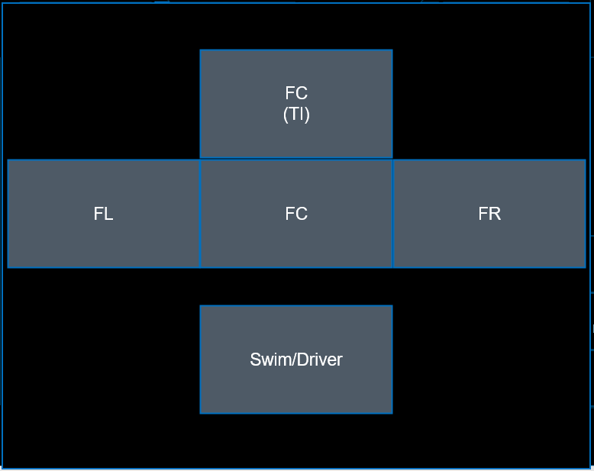

(L0_X, L0_Y)

L0_W

(L1_X, L1_Y)

(L3_X, L3_Y)

(L4_X, L4_Y)

(L2_X, L2_Y)

L0_H

L3_H

L1_H

L4_H

L3_W

L2_W

L1_W

L4_W

L2_H

Frame Width

Frame Height

VDS_Setup_Request

|  |  |  |  |  |
| --- | --- | --- | --- | --- |
| VDS_Setup_Request  Repetition Rate: On Request | | | | |
| Octet | 0 | 1 | 2 | 3 |
| 0 | MsgHeader: 0x5354 | | MsgType: 0x10 | MsgVersion: 0x00 |
| 4 | SequenceNumber: 1 | | | |
| 8 | Timestamp since epoch | | | |
| 12 |
| 16 | 192 | 168 | 31 | 101 |
| 20 | Port: 8001 | | Reserved: 0x0000 | |
| 24 | FrameWidth: 1920 | | FrameHeight: 1024 | |
| 28 | CompressFormat: 0 | ComputeId: 0 | FPS: 30 | NumLayouts: 5 |
| 32+0*12+0 | VideoSrcId: 0 | FlipHV: 0 | Reserved | Reserved |
| 32+0*12+4 | L0_X | | L0_Y | |
| 32+0*12+8 | L0_W | | L0_H | |
| 32+1*12+0 | VideoSrcId: 1 | FlipHV: 0 | Reserved | Reserved |
| 32+1*12+4 | L1_X | | L1_Y | |
| 32+1*12+8 | L1_W | | L1_H | |
| 32+2*12+0 | VideoSrcId: 2 | FlipHV: 0 | Reserved | Reserved |
| 32+2*12+4 | L2_X | | L2_Y | |
| 32+2*12+8 | L2_W | | L2_H | |
| 32+3*12+0 | VideoSrcId: 3 | FlipHV: 0 | Reserved | Reserved |
| 32+3*12+4 | L3_X | | L3_Y | |
| 32+3*12+8 | L3_W | | L3_H | |
| 32+4*12+0 | VideoSrcId: 4 | FlipHV: 0 | Reserved | Reserved |
| 32+4*12+4 | L4_X | | L4_Y | |
| 32+4*12+8 | L4_W | | L4_H | |

#### Teardown Stream Command Message

| **ID No** | **REQUIREMENTS** |
| --- | --- |
|  | The Video Server shall receive “Setup Stream” command message from Platform Server. |
|  | The Video Server shall receive “Teardown Stream” command message from Platform Server. |
|  | Upon receiving Teardown Stream, Video Server it shall broadcast an Acknowledge message back to Platform Server. |
|  | Video Server shall identify the requested RTP stream based on IP address and port number and terminate the RTP stream and RTP Stamp. |

VDS_Teardown_Request

|  |  |  |  |  |
| --- | --- | --- | --- | --- |
| **VDS_Teardown_Request**  Repetition Rate: On Request | | | | |
| Octet | 0 | 1 | 2 | 3 |
| 0 | MsgHeader | | MsgType | MsgVersion |
| 4 | SequenceNumber | | | |
| 8 | Timestamp | | | |
| 12 | Timestamp | | | |
| 16 | IP-Address(0) | IP-Address(1) | IP-Address(2) | IP-Address(3) |
| 20 | Port | | Reserved | |

Data description

|  |  |  |  |  |
| --- | --- | --- | --- | --- |
| **Field** | **Data Type** | **Resolution** | **Range** | **Remarks** |
| Header | UINT16 |  |  | A fixed message header: 0x5354 |
| Type | UINT8 |  |  | Message type:  0x00: Undefined  0x01: Heartbeat  0x02: Acknowledge  0x10: Stream Setup  0x11: Stream Teardown |
| SequenceNumber | UINT32 |  |  | Running sequence number |
| Timestamp | UINT64 | 1us / bit | 0…2^64 | Time since epoch in microseconds |
| IP-Address | UINT32 |  |  | IP Address of RTP to be terminated |
| Port | UINT16 |  |  | Port Number of RTP to be terminated |

#### Stream List Request Message

| **ID No** | **REQUIREMENTS** |
| --- | --- |
|  | The Video Server upon receiving a Stream List Request message from Platform Server shall publish a Stream List to Platform Server. |

VDS_Stream List_Request

|  |  |  |  |  |
| --- | --- | --- | --- | --- |
| **VDS_Stream_List_Request**  Repetition Rate: On Request | | | | |
| Octet | 0 | 1 | 2 | 3 |
| 0 | MsgHeader | | MsgType | MsgVersion |
| 4 | SequenceNumber | | | |
| 8 | Timestamp | | | |
| 12 | Timestamp | | | |

Data description

|  |  |  |  |  |
| --- | --- | --- | --- | --- |
| **Field** | **Data Type** | **Resolution** | **Range** | **Remarks** |
| Header | UINT16 |  |  | A fixed message header: 0x5354 |
| Type | UINT8 |  |  | Message type:  0x21: Stream List Request |
| SequenceNumber | UINT32 |  |  | Running sequence number |
| Timestamp | UINT64 | 1us / bit | 0…2^64 | Time since epoch in microseconds |

VDS_Stream List

|  |  |  |  |  |
| --- | --- | --- | --- | --- |
| **VDS_Stream_List**  Repetition Rate: On Request | | | | |
| Octet | 0 | 1 | 2 | 3 |
| 0 | MsgHeader | | MsgType | MsgVersion |
| 4 | SequenceNumber | | | |
| 8 | Timestamp | | | |
| 12 | Timestamp | | | |
| 16 | NumStreams (S) | Reserved | TotalStreamSize | |
| 20 | IP-Address(0) | IP-Address(1) | IP-Address(2) | IP-Address(3) |
| 24 | Port | | Reserved | |
| 28 | FrameWidth | | FrameHeight | |
| 32 | CompressFormat | ComputeId | FPS | NumLayouts |
| 36+L*12+0 | VideoSrcId | FlipHV | Reserved | Reserved |
| 36+L*12+4 | Layout_X | | Layout_Y | |
| 36+L*12+8 | Layout_Width | | Layout_Height | |
| 20+S1+0 | IP-Address(0) | IP-Address(1) | IP-Address(2) | IP-Address(3) |
| 20+S1+4 | Port | | Reserved | |
| 20+S1+8 | FrameWidth | | FrameHeight | |
| 20+S1+12 | CompressFormat | ComputeId | FPS | NumLayouts (N) |
| 20+S1+12+L*12+0 | VideoSrcId | FlipHV | Reserved | Reserved |
| 20+S1+12+L*12+4 | Layout_X | | Layout_Y | |
| 20+S1+12+L*12+8 | Layout_Width | | Layout_Height | |

Stream 2

Stream 1

Data description

|  |  |  |  |  |
| --- | --- | --- | --- | --- |
| **Field** | **Data Type** | **Resolution** | **Range** | **Remarks** |
| Header | UINT16 |  |  | A fixed message header: 0x5354 |
| Type | UINT8 |  |  | Message type:  0x22: Stream List |
| SequenceNumber | UINT32 |  |  | Running sequence number |
| Timestamp | UINT64 | 1us / bit | 0…2^64 | Time since epoch in microseconds |
| NumStreams | UINT8 |  |  | Total number of RTP streams being output by Video Server |
| TotalStreamSize | UINT16 |  |  | Total Stream size in bytes |
| IP Address |  |  |  | IP Address of Stream 1…N |
| Port |  |  |  | Port of Stream 1…N |
| FrameWidth |  |  |  | Frame Width of Stream 1…N |
| FrameHeight |  |  |  | Frame Height of Stream 1…N |
| CompressFormat |  |  |  | Compress Format of Stream 1…N |
| ComputeId |  |  |  | Compute Id of Stream 1…N |
| FPS |  |  |  | FPS of Stream 1…N |
| NumLayouts |  |  |  | Number of Layouts of Stream 1…N |
| VideoSrcId |  |  |  | Video Source ID of Layout 1…M of Stream 1…N |
| FlipHV |  |  |  | Flip operation of Layout 1…M of Stream 1…N |
| Layout_X |  |  |  | Layout X position of Layout 1…M of Stream 1…N |
| Layout_Y |  |  |  | Layout Y position of Layout 1…M of Stream 1…N |
| Layout_Width |  |  |  | Layout Width of Layout 1…M of Stream 1…N |
| Layout_Height |  |  |  | Layout Height of Layout 1…M of Stream 1…N |

#### Acknowledgement Message

| **ID No** | **REQUIREMENTS** |
| --- | --- |
|  | The Video Server upon receiving a Setup Video Request or Teardown Video request, shall publish an Acknowledgement message within 100ms. |
|  | The Video Server shall do a check and reply in the AckStatus whether the request can be served.  0x00: Not Acknowledged (Request cannot be served)  0x01: Acknowledged (Request can be served) |
|  | If Platform Server does not receive any Acknowledgement message from Video Server within 100ms, Platform Server shall resend the command message with a sequence number increment by 1. |

Acknowledge Message

|  |  |  |  |  |
| --- | --- | --- | --- | --- |
| VDS_Acknowledge  Repetition Rate: On Request | | | | |
| Octet | 0 | 1 | 2 | 3 |
| 0 | Header | | Type | Version |
| 4 | SequenceNumber | | | |
| 8 | Timestamp | | | |
| 12 | Timestamp | | | |
| 16 | AckSequenceNumber | | | |
| 20 | AckStatus | Reserved | Fault Codes | |

Data description

|  |  |  |  |  |
| --- | --- | --- | --- | --- |
| **Field** | **Data Type** | **Resolution** | **Range** | **Remarks** |
| Header | UINT16 |  |  | A fixed message header: 0x5354 |
| Type | UINT8 |  |  | Message Type:  0x00: Undefined  0x01: Heartbeat  0x02: Acknowledge  0x10: Stream Setup  0x11: Stream Teardown |
| Version | UINT8 |  |  | Message Version: 0x00 |
| SequenceNumber | UINT32 |  |  | Running sequence number from 0 |
| Timestamp | UINT64 | 1us / bit | 0…2^64 | Time since epoch in microseconds |
| AckSequenceNumber | UINT32 |  |  | The sequence number of the command message that was acknowledged |
| AckStatus | UINT8 |  | 0..1 | 0x00: Not Acknowledge  0x01: Acknowledge |
| FaultCode | UINT16 |  | 0..1 | Fault code. See table |

FaultCodes (To be reviewed)

|  |  |  |
| --- | --- | --- |
| **Byte** | **Bit** | **Parameter** |
| 1 | 1(LSB) | Invalid Sequence Number |
| 2 | Invalid Message Type |
| 3 | Invalid Destination RTP IP Address |
| 4 | Invalid Destination RTP Port number |
| 5 | Invalid Frame Width |
| 6 | Invalid Frame Height |
| 7 | Invalid Compress Format |
| 8(MSB) | Invalid Compute Id |
| 2 | 1(LSB) | Invalid Layout Parameter |
| 2 |  |
| 3 |  |
| 4 |  |
| 5 |  |
| 6 |  |
| 7 |  |
| 8(MSB) |  |
| 3 | 1(LSB) |  |
| 2 |  |
| 3 |  |
| 4 |  |
| 5 |  |
| 6 |  |
| 7 |  |
| 8(MSB) |  |

#### RTP Message

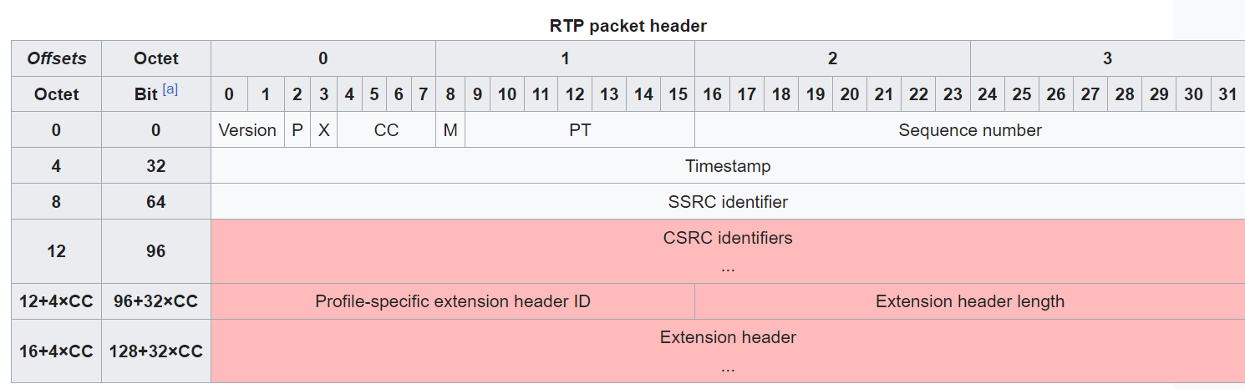

|  |  |
| --- | --- |
| **Field** | **Description** |
| Version | Indicates the version of the protocol. Current version is 2 |
| P (Padding) | Used to indicate if there are extra padding bytes at the end of the RTP packet. Padding may be used to fill up a block of certain size, for example as required by an encryption algorithm. The last byte of the padding contains the number of padding bytes that were added (including itself). |
| X (Extension) | Indicates presence of an extension header between the header and payload data. The extension header is application or profile specific. |
| CC (CSRC count) | Contains the number of CSRC identifiers (defined below) that follow the SSRC. |
| M (Marker) | Signaling used at the application level in a profile-specific manner. If it is set, it means that the current data has some special relevance for the application. |
| PT (Payload type) | Indicates the format of the payload and thus determines its interpretation by the application. Values are profile specific and may be dynamically assigned. |
| Sequence Number | The sequence number is incremented for each RTP data packet sent and is to be used by the receiver to detect packet loss[[3]](https://en.wikipedia.org/wiki/Real-time_Transport_Protocol#cite_note-Hardy_298-3) and to accommodate [out-of-order delivery](https://en.wikipedia.org/wiki/Out-of-order_delivery). |
| Timestamp | Used by the receiver to play back the received samples at appropriate time and interval.  The timestamp is defined as the system time where the camera frame is captured or grabbed. This is important as the time will be used to synchronize multiple camera frames for video analytics.  The timestamp unit is in milli-seconds. |
| SSRC Identifier | Synchronization source identifier uniquely identifies the source of a stream. The synchronization sources within the same RTP session will be unique. |
| CSRC Identifier | Contributing source IDs enumerate contributing sources to a stream which has been generated from multiple sources. |

VDS_RTPStamp Message

|  |  |  |  |  |
| --- | --- | --- | --- | --- |
| VDS_RTPStamp  Repetition Rate: On Request | | | | |
| Octet | 0 | 1 | 2 | 3 |
| 0 | Header | | Type | Version |
| 4 | SequenceNumber | | | |
| 8 | Timestamp | | | |
| 12 | Timestamp | | | |
| 16 | RTP Sequence Number | | Fault code | |

Data description

|  |  |  |  |  |
| --- | --- | --- | --- | --- |
| **Field** | **Data Type** | **Resolution** | **Range** | **Remarks** |
| Header | UINT16 |  |  | 0x5354 |
| Type | UINT8 |  |  | Message Type:  0x00: Undefined  0x01: Heartbeat  0x02: Acknowledge  0x10: Stream Setup  0x11: Stream Teardown  0x20: RTP Stamp |
| Version | UINT8 |  |  | 0x00 |
| SequenceNumber | UINT32 |  |  | Running sequence number from 0 |
| Timestamp | UINT64 | 1us / bit | 0…2^64 | Time since epoch in microseconds |
| RTP Sequence Number | UINT16 |  |  | The corresponding RTP Sequence Number |
| FaultCode | UINT16 |  |  | Bit mask of a list of faults (TBD) |

#### VDS_ListStreams Message

In the event of Platform Server being rebooted while Video Server is outputting RTP streams to its client, Platform Server can send the VDS_ListStreams messages to Video Server to get the stream information.

### Image Recovery

| **ID No** | **REQUIREMENTS** |
| --- | --- |
|  | In the event of a detection of a loss of communication of RTP stream data from Video Server, Platform Server shall publish RTP_Setup message. |
|  |  |
|  |  |

## Safety Features

| **ID No** | **REQUIREMENTS** |
| --- | --- |
|  | Not Applicable |
|  |  |
|  |  |

## Performance requirements

| **ID No** | **REQUIREMENTS** |
| --- | --- |
|  | Not Applicable |

# Use Case Analysis Model

## Actor List

| **ACTOR** | **CHARACTERISTICS** |
| --- | --- |
|  | Not Applicable |

## Use Case Modelling

The Use Case diagram shows the interaction between Video Server and other actors.

## Use Case

Not Applicable

# Design Constraints / Limitation

### Hardware Constraints / Limitation

| **ID No** | **CONSTRAINTS / LIMITATION** |
| --- | --- |
|  | Not Applicable |

### Software Constraints / Limitation

| **ID No** | **CONSTRAINTS / LIMITATION** |
| --- | --- |
|  | Not Applicable |

# Software System Atributes

### Reliability

| **ID No** | **REQUIREMENTS** |
| --- | --- |
|  | Not Applicable |

### 

### Availability

| **ID No** | **REQUIREMENTS** |
| --- | --- |
|  | Not Applicable |

### Security

| **ID No** | **REQUIREMENTS** |
| --- | --- |
|  | Not Applicable |

### Maintainability

| **ID No** | **REQUIREMENTS** |
| --- | --- |
|  | Not Applicable |

### Portability

| **ID No** | **REQUIREMENTS** |
| --- | --- |
|  | Not Applicable |

# Other Requirements

| **ID No** | **REQUIREMENTS** |
| --- | --- |
|  | Not Applicable |

# Annex

